2017-19 Biennium Budget
Decision Package

Agency: 355 Department of Archaeology and Historic Preservation

Decision Package Code/Title: AJ - Asst. State Anthro/Skeletal Remains Asst. Acct.

Budget Period: 2017-19

Budget Level: PL – Performance Level

Agency Recommendation Summary Text:
The Department of Archaeology and Historic Preservation (DAHP) is requesting funding for the continuation of the Skeletal Human Remains Assistance Account (SHRAA) and the Assistant State Physical Anthropologist (APA) position which is funded through the account. The SHRAA provides grant assistance to private property owners and tribes, as well as state and local government agencies when human remains are discovered and need to be recovered and reburied. The APA position is one of two staff supporting the Human Skeletal Remains program. Funding from the account is granted to property owners to assist with hiring an archaeological firm when the scope of a project is too big for DAHP staff and requires a larger crew. As the State Physical Anthropologist receives a new case every four days, the APA position is critical to the timely recovery and repatriation of human remains. This past year, the APA’s analysis of Pacific Northwest human remains became critical to the Army Corps of Engineers determination that Kennewick Man was indeed Native American.

Fiscal Summary: Decision package total dollar and FTE cost/savings by year, by fund, for 4 years. Additional fiscal details are required below.

Operating Expenditures | FY 2018 | FY 2019 | FY 2020 | FY 2021
Fund 14P-6 | 250,000 | 250,000 | 250,000 | 250,000
Total Cost | Xxx | yyy | zzz | aaa
Staffing | FY 2018 | FY 2019 | FY 2020 | FY 2021
FTEs | 1.0 | 1.0 | 1.0 | 1.0
Revenue | FY 2018 | FY 2019 | FY 2020 | FY 2021
None | 0 | 0 | 0 | 0
Object of Expenditure | FY 2018 | FY 2019 | FY 2020 | FY 2021
Obj. A | 73,200 | 75,000 | 75,000 | 75,000
Obj. B | 27,500 | 27,800 | 27,800 | 27,800
Obj. E | 149,300 | 147,200 | 147,200 | 147,200

Package Description

The Department of Archaeology and Historic Preservation (DAHP) is the State’s regulatory agency for cultural and historic resources protection. In 2008, the legislature passed HB 2624, which created the position of the State Physical Anthropologist, giving DAHP jurisdiction over non-forensic human skeletal remains found throughout the state of Washington. At the same time, the legislature created the Skeletal Human Remains Assistance Account (SHRAA) to assist property owners when human remains are discovered by helping them with the cost of removal and reburial per RCW 27.44.040 or RCW 68.60. As of the end of fiscal year 2017, the SHRAA will be depleted.

Prior to 2008 there was no procedure for the notification, identification, and removal of Native American remains, leaving law enforcement and property owners without a path forward. Yet removal of human remains without a permit was still a felony. Therefore, in 2008 the legislature established a program for identifying and removing all historic human remains, Indian and non-Indian, and created the position of State Physical Anthropologist. The concept of a Human Skeletal Remains program was created for the benefit of both affected tribes and property owners. If the State could remove remains either through staff or through grant assistance, property owners would then have an incentive to report remains when they are found. The remains could be removed quickly allowing property owners to proceed with their projects without much delay.

During the Great Recession, DAHP lost funding for the position of the Assistant State Physical Anthropologist (APA), despite the fact that the workload had increased. An emergency situation at the Wanapum Dam led the legislature to restore the APA position for the 2015-17 biennium as the workload was far greater than DAHP’s one anthropologist could manage. Past and present caseload continues to outstrip the State Physical Anthropologist’s ability to investigate each case, from meeting the statutory timeliness of notifications to affected parties to successfully handling the disposition of human remains cases. The number of human remains cases has steadily increased with an average of one new case every four days, requiring travel to various locations throughout the state; a workload which requires a minimum of two full-time FTEs.

The State Physical Anthropologist currently handles a caseload of between 40 and 60 human skeletal remains cases a year (Figure 1). Since the appointment of the State Physical Anthropologist in August of 2008, DAHP has opened and investigated 433 human skeletal remains cases representing at least 626 individuals. A projected additional 33 cases is anticipated for the remainder of the 2016 calendar year bringing the current year’s total case load to 66 non-forensic human skeletal remains cases (the highest yearly caseload yet) and the total cases opened to 466 cases.

The present case rate of one new human remains case every four DAHP business days, makes it impossible to coordinate meetings with interested affected tribes with only one staff person in the program. Such meetings are critical for arranging repatriations or reburials of Native American remains or to arrange for dispositions of non-Indian remains, which is required by state law.

Currently, the DAHP houses human skeletal remains from 133 cases representing the remains of at least 220 individuals. The addition of the APA position in July of 2014 resulted in the successful disposition of human remains associated with 46 cases (representing at least 71 individuals). The increase in timely repatriations as a result of the hiring of the APA position is evident in Figure 2 for 2014 and 2015 calendar years. DAHP has opened 109 cases since hiring the APA and in that time the disposition rate has increased from a steady 56% to over 70%. It is estimated that at the current rate of disposition, assuming the caseload remains steady, retention of the APA will bring the disposition rate up to 100% by 2023.

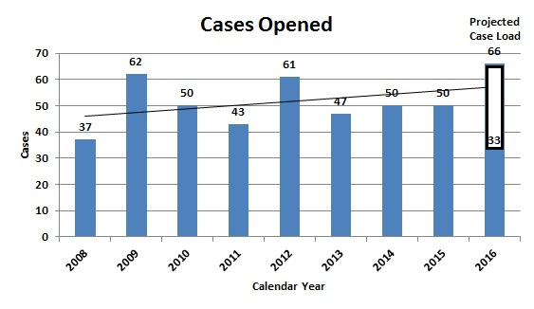
Figure 1. Numbers of Non-Forensic Human Skeletal Remains Cases Received
(data for calendar year 2008 includes only August through the end of December
and for calendar year 2016 only through the end of June).

Without continuation of the APA position, the number of cases held at the DAHP will rise above the pre-2015 FY levels and the volume of human remains will exceed the agency’s storage capacity in the human remains laboratory. Loss of the position will also hamper the ability of the State Physical Anthropologist to respond to inadvertent finds of human skeletal remains on construction projects.

The State Physical Anthropologist composes a written case report for each non-forensic human skeletal remains case investigated. These reports summarize the circumstances revolving around the discovery of the remains, the results of the State Physical Anthropologist’s statutory requirement for a determination of ethnicity, the relevant tribes notified and identified as interested affected tribes, and the final disposition of those remains. Prior to the hiring of the APA, case report completion held flat with only 17% of the cases having a completed report. With the hiring of the APA in July 2014, completed case reports have nearly doubled and nearly one quarter of all cases have completed reports (Figure 3). In addition to case reports completed, the APA completed 19 archaeological site forms and additions to the cemetery

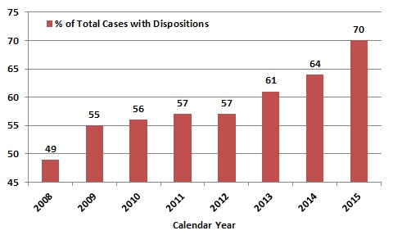
Figure 2. Percentage of the cumulative total number of cases with dispositions per calendar year (data for calendar year 2008 includes only August through the end of December and calendar year 2016
was not included because of only partial data available for that year).

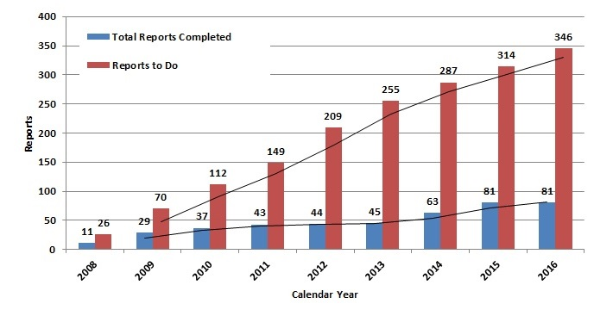
Figure 3. Total Numbers of Case Reports Completed and Backlog of Reports to Complete
(data for calendar year 2008 includes only August through the end of December
and for calendar years 2016 only through June).

database and GIS system. A loss of the APA position will result in uncompleted case reports which will be a legal liability to the state. Reports are necessary to prove what was recovered by the state, the process of identification, and to document the repatriation.

In 2008, along with the creation of the Human Skeletal Remains program, DAHP was tasked by the legislature with the creation of a cemetery database and geographic information system to track all Washington’s cemeteries. Prior to this, there was no one database that held all information on Native American, historic, and abandoned cemeteries. Until 2014, the Human Skeletal Remains program’s Cartographer 1 carried out the duties of tracking cemeteries in the database. In order to save state resources, when the Cartographer 1 retired, the position was held vacant. The loss of the Cartographer 1 position means that the State Physical Anthropologist is now maintaining and updating DAHP’s cemetery database and geographic information system which currently houses information on over 2,800 cemeteries and burial sites across the state. The consequences of the State Physical Anthropologist not covering the duties of the Cartographer are project delays through inadvertent discoveries of abandoned cemeteries graves and burials throughout the state.

The continuation of the APA position is necessary to continue timely completion of notifications and repatriation and reburial of Native and non-Native remains, which prevents delays for property owners when human remains are discovered during a project, and the continued effort to reduce the huge backlog of case reports to be completed. Since the original appropriation to the SHRAA by the legislature in 2008, the agency has been able to pay for numerous recoveries and re-interments of human remains finds throughout the state. Over the eight years since its creation, DAHP has received requests for funds totaling $670,959.87 and has been able to award $233,433.72 to private property owners and tribes to help cover the costs of excavation and re-interment (Figure 4). Between the awarding of grants and funding the APA position, the account will be depleted by the end of FY 2017.

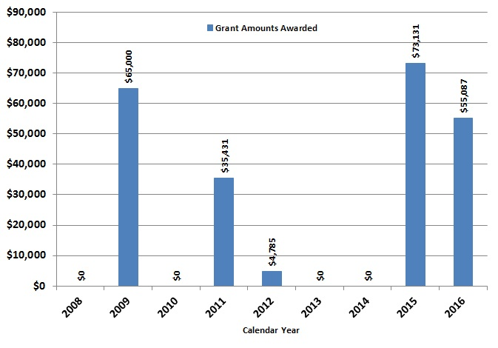

Figure 4. Grant amounts awarded from the HSRAA by calendar year (2008 only includes data
from August 2008 and 2016 represents only through June).

This proposed package to replenish the HSRAA and to continue to fund from that account the APA position meets Goal 3 of the agency’s strategic plan, which states “Strengthen policies and planning processes to enhance informed and cross-disciplinary decision-making for managing cultural and historic resources.” It also directly supports the plan’s strategy 3.A. (ii) that directs DAHP to: “Increase opportunities for timely and effective consultation between Tribal cultural and historic preservation officials and land use decision-makers to ensure that Tribes have a meaningful role in land-use decision-making that affects Native American cultural and historic sites.”

Base Budget: If the proposal is an expansion or alteration of a current program or service, provide information on the resources now devoted to the program or service.

The position funded from this request is a Forensic Scientist 3 Range 62, Step G.
Annual salary: $73,140.80, Annual Benefits: $27,413.16

This is not an expansion or alteration but merely a maintenance request for depleted funds.

Decision Package expenditure, FTE and revenue assumptions, calculations and details:

Agencies must clearly articulate the workload or policy assumptions used in calculating expenditure and revenue changes proposed.

As stated above, and shown in accompanying charts, the workload for the State Physical Anthropologist, in addition to grant requests, is no longer sustainable. The agency is requesting that the SHRAA account be reestablished at $500,000 to continue funding for the APA position and to continue to provide assistance to property owners when remains are encountered, as an ongoing request.

Decision Package Justification and Impacts
What specific performance outcomes does the agency expect?
Describe and quantify the specific performance outcomes the agency expects as a result of this funding change.

The funding of this decision package will provide for the continuation of the APA position funded from the SHRAA. This results in near immediate response times by the State Physical Anthropologist to all inadvertent human skeletal remains finds within the state of Washington, preventing unnecessary and costly lengthy construction project delays when human remains are encountered. The APA position also means quicker resolution for repatriation and for completing legally responsible and necessary case reports.

DAHP’s secure lab facility currently holds human skeletal remains from 133 cases representing the remains of at least 220 individuals. With the current case rate, the State Physical Anthropologist cannot arrange for the disposition of these remains while assisting other recovery efforts. The continuation of the APA position assures the number of unclosed cases significantly declines and limits the time and the number of human remains being temporarily stored at DAHP.

The APA position also covers the duties of the Cartographer 1 position lost in 2015 due to budget reductions. This includes assisting the State Physical Anthropologist with meeting mandatory notification timelines and the collection and maintenance of the DAHP’s cemeteries, graves, and burial sites database and GIS layer as required under RCW 27.34.415. Without the APA position there is no one available in the agency to perform this mandated function. The agency has only one Administrative Assistant 3 and one office assistant to cover a staff of 20. The consequences of not covering the duties of the Cartographer 1 are project delays or failures due to the lack of information on cemeteries, graves, and burial sites.

The continuation of the APA position and replenishment of the SHRAA meets the Governor’s Results Washington Goal 5 1.1 (increase percentage of agency core services), 1.1a (increase percentage of agencies measuring customer satisfactions), 1.2. (increase percentage of agency core services timeliness) and 1.2.a (increase percentage of agencies measuring timeliness) performance initiative by giving DAHP the ability to be more effective, efficient, and accountable when human skeletal remains are found throughout the state of Washington. By efficiently handling the inadvertent discovery of human remains and abandoned cemeteries DAHP will prevent project delays.

Performance Measure detail:

001415 – The percentage of human remains cases reported to Tribes annually in a timely manner.
Description: The agency will report these cases to Tribes in a timely manner as per statute language.

Reported on Annually – Target is 100%. Actual Current (FY2015): 26.5%, 100% of inadvertent finds are reported within statutory requirements. Projected: 40%, continuation of 100% of all inadvertent finds within statutory requirements.

002683 – Number of updates made to the Cemetery Database, annually.
Description: The number of updates, changes, corrections, made annually to the Cemetery Database.

Reported on Annually – (no target specified). Actual Current (FY2015): 31 Projected: 50.

Fully describe and quantify expected impacts on state residents and specific populations served.

Private property owners and federal, state, and local government agencies who inadvertently encounter skeletal human remains during construction projects will continue to experience quick response from the State Physical Anthropologist and the APA, and enjoy relatively short project delays. Removal of remains that could not be done by the State Physical Anthropologist and the APA directly could apply for grant funding to have the work completed through qualified archaeologists.

Tribes will continue to receive timely notifications of inadvertent human skeletal remains finds throughout the state.

What are other important connections or impacts related to this proposal? Please complete the following table and provide detailed explanations or information below:

Impact(s) To: |  | Identify / Explanation
Regional/County impacts? | Yes | Identify: The APA position will allow faster and more efficient response to human remains finds found during improvement projects across the state being conducted by counties.
Other local gov’t impacts? | Yes | Identify: The APA position will allow faster and more efficient response to human remains finds found during improvement projects across the state being conducted by local governments.
Tribal gov’t impacts? | Yes | Identify: The APA position will allow faster and more efficient response to human remains finds found during improvement projects across the state. Tribes will see improved response times to cases where tribal ancestral remains are involved.
Other state agency impacts? | Yes | Identify: The APA position will allow faster and more efficient response to human remains finds found during improvement projects across the state being conducted by other state agencies.
Responds to specific task force, report, mandate or exec order? | No | Identify: The package does not respond to a specific task force, report, mandate or exec order.
Does request contain a compensation change? | No | Identify: There are no required compensation changes.
Does request require a change to a collective bargaining agreement? | No | Identify: There are no required changes to a collective bargaining agreement.
Facility/workplace needs or impacts? | No | Identify: There are no facility/workplace needs or impacts.
Capital Budget Impacts? | No | Identify: No capital budget impact.
Is change required to existing statutes, rules or contracts? | No | Identify: No changes to existing statutes, rules, or contracts are required.
Is the request related to or a result of litigation? | No | Identify lawsuit (please consult with Attorney General’s Office): No litigation relationship.
Is the request related to Puget Sound recovery? | No | If yes, see budget instructions Section 14.4 for additional instructions No relation to Puget Sound recovery.
Identify other important connections

Please provide a detailed discussion of connections/impacts identified above.

What alternatives were explored by the agency and why was this option chosen?

Caseload dictates the required needs of staffing. At present, the caseload exceeds the ability of one staff person to adequately respond. DAHP has investigated possible alternatives to the continuation of the APA position, including using unpaid internships and graduate students. Unfortunately, neither of these has the necessary expertise required to perform the duties. In addition, DAHP investigated the possibility of continuing only at a 0.5 FTE position, but the current and projected case load and resolution of the backlog of cases requires a full FTE to complete the work.

While the single State Physical Anthropologist along with the APA has been able to conduct recoveries and reburial of remains over the years of the program, there is simply not enough staff to perform this work and the fund is the only way in which private landowners, tribes, and local governments can pay for the work to be performed.

What are the consequences of not funding this request?

Not funding this request would result in the elimination of the APA position and the discontinuation of assistance to private landowners in excavation and reburial of human remains. Increasing caseloads will adversely affect the relationship between the State, job producing projects, and tribes. There is a serious potential of the State incurring excessive financial costs for delays in making a satisfactory resolution of human skeletal remains finds, especially finds that cause project delays and cultural impacts affecting tribal ancestry. The hiring of the APA position has created quicker responses to inadvertent human remains finds. For example, a recent inadvertent human remains case involving a septic system replacement in Island County was completed from discovery, to identification of the remains as Indian, to notification of affected tribes, identification of affected tribes, and repatriation of the remains in seven business days. An inadvertent find of human remains on a RV dealership expansion project in Yakima County was handled by the APA in five business days, although the property owner was able to start his project again in three days. Without the APA position the identification and removal process could take weeks as a property owner would need to hire an archaeological consulting firm at their own cost.

Failure to replenish the SHRAA will require that private landowners pay for human skeletal remains excavation and reburial when a project is simply too large for DAHP staff and archaeological consultants are necessary. Without full or partial reimbursement, property owners will not have an incentive to report findings to law enforcement and county coroner’s offices throughout the state.

How has or can the agency address the issue or need in its current appropriation level?

The legislature identified the need for the APA position in FY 2015 and in the 2015-2017 biennium and funded the position by drawing from the SHRAA. The caseload for the past eight years has clearly demonstrated the need for a permanent APA position. The APA position will expire in June of 2017 now that funds in the account are depleted. There is no way the agency can address the need in its current appropriation level beyond the current biennium and the SHRAA cannot fund further grants in the new biennium unless a new appropriation is approved.

Other supporting materials: Please attach or reference any other supporting materials or information that will help analysts and policymakers understand and prioritize your request.

Information technology: Does this Decision Package include funding for any IT-related costs, including hardware, software, services (including cloud-based services), contracts or IT staff?
☒ No
☐ Yes Continue to IT Addendum below and follow the directions on the bottom of the addendum to meet requirements for OCIO review.)

